Qiling Ma

Art 107 - Advanced Projects in Digital Media

Professor Hott

September 30, 2019

Research Plan & Proposal

My Proposal Slide Link: <https://docs.google.com/presentation/d/1NA-Q1WQAvveeuQRux-H_0Pn6IgGbZv-Lif1UH3krp1k/edit?usp=sharing>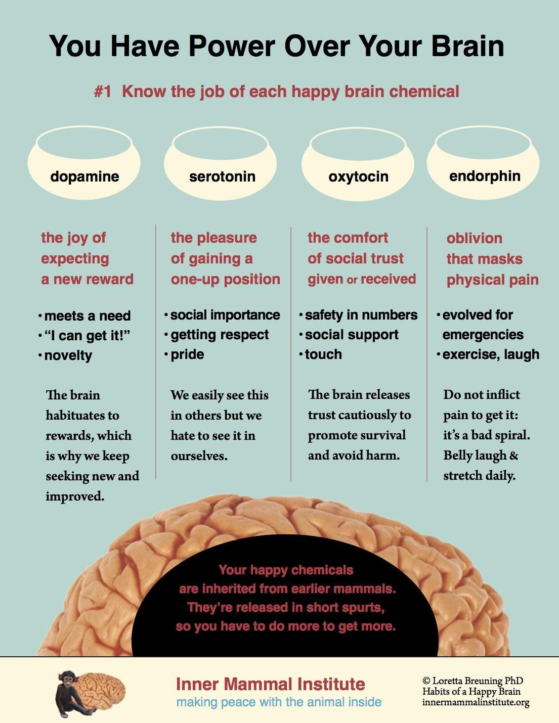

The system I want to explore is how our brains process feelings of joy. According to Dr. Loretta G. Breuning’s article, “we have two different brain systems – the limbic system and the cortex – which keep us alive and protect our DNA. The limbic system produces the neurochemicals that tell your body what’s good or bad for you. It’s a survival mechanism: in the presence of something good, the brain releases four main ‘feel good’ chemicals – endorphin, oxytocin, serotonin, and dopamine – and in the presence of danger, the ‘bad feeling’ chemical – cortisol – comes in.” By establishing some habits can increase our happy chemicals in our brains and we will feel happy in life.

The reason why I want to explore the system of happiness in our brains is that I have been feeling plain, unhappy and anxious for a long time. It doesn’t mean I am not happy every day. Just I feel happy in a very short time and then the happiness went so fast. And I come back into an unhappy or anxious state. I couldn’t remember when was the last time I felt wildly happy. I have tried to follow the people around me to do things that will usually make them happy. I tried shopping, learning instruments, watching movies, doing exercising. Still, I feel confused and anxious, unhappy. I don’t know how to balance happiness and negative feelings in my heart. The older I have grown, the more burden and stress I have felt.

By exploring the system of happiness in our brains, I hope I can learn more about my feelings and myself. I believe creating art is a healing process for me. I hope I can find ways to gain happiness and test if the happy chemical theory works for me or not. I want to create 3 art projects to document my exploration process and share the research results with my audience. I hope people who feel unhappy all the time like me can find ways to gain happiness and be happy when they interact with my art projects.

For the first art project, I will need to do research on the science of happiness by reading books and online videos. Then I will summaries some knowledge points of the system and methods to practice how to make us happy. I want to create a video to share the research results with my audience. Since the system of happiness in our brains is invisible, I will use the motion graphics video to explain the concepts of the system and how the system works.

For the second art project, I will practice the methods I learned from the research. Then using the AR experience to show my process of pursuing happiness. Or I will make 3d modeling and animation to present the happy moments in my exploration. In these ways, I want to motivate the audience to try to use these methods to increase their happiness.

For the last art project, I want to create an Arduino interactive installation to track their happy level while they are interacting with the former two projects. I want to encourage my audience to look for their ways to be happy. Or I want to create an Arduino interactive installation to make my audience laugh and record their laughter or smiles and show them to the audience.

References:

<https://www.psychologytoday.com/files/attachments/59029/happy-chemicals.pdf>

<https://www.psychologies.co.uk/self/how-to-boost-your-natural-feelgood-chemicals.html>

<https://www.tonyrobbins.com/mental-health/science-of-happiness/>

<https://innermammalinstitute.org/>